Toeplitz Matrix

Def

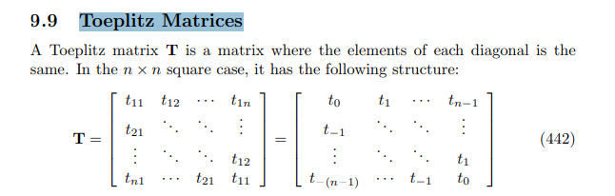

Property

Persymmetric

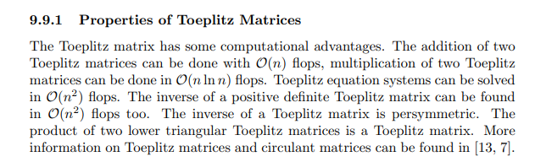

Ref

[Wayback Machine (archive.org)](https://web.archive.org/web/20090521075124/http://www2.imm.dtu.dk/pubdb/views/edoc_download.php/3274/pdf/imm3274.pdf)